150

MONOPOLY

WHAT’S NEW IN THE SEVENTH EDITION:

A new In the News box on “Price Discrimination in Higher Education” has been added.

LEARNING OBJECTIVES:

By the end of this chapter, students should understand:

➢ why some markets have only one seller.

➢ how a monopoly determines the quantity to produce and the price to charge.

➢ how the monopoly’s decisions affect economic well-being.

➢ why monopolies try to charge different prices to different customers.

➢ the various public policies aimed at solving the problem of monopoly.

CONTEXT AND PURPOSE:

Chapter 15 is the third chapter in a five-chapter sequence dealing with firm behavior and the organization of industry. Chapter 13 developed the cost curves on which firm behavior is based. These cost curves were employed in Chapter 14 to show how a competitive firm responds to changes in market conditions. In Chapter 15, these cost curves are again employed, this time to show how a monopolistic firm chooses the quantity to produce and the price to charge. Chapters 16 and 17 will address the decisions made by monopolistically competitive, and oligopolistic firms. A monopolist is the sole seller of a product without close substitutes. As such, it has market power because it can influence the price of its output. That is, a monopolist is a price maker as opposed to a price taker. The purpose of Chapter 15 is to examine the production and pricing decisions of monopolists, the social implications of their market power, and the ways in which governments might respond to the problems caused by monopolists.

KEY POINTS:

• A monopoly is a firm that is the sole seller in its market. A monopoly arises when a single firm owns a key resource, when the government gives a firm the exclusive right to produce a good, or when a single firm can supply the entire market at a lower cost than many firms could.

• Because a monopoly is the sole producer in its market, it faces a downward-sloping demand curve for its product. When a monopoly increases production by one unit, it causes the price of its good to fall, which reduces the amount of revenue earned on all units produced. As a result, a monopoly’s marginal revenue is always below the price of its good.

• Like a competitive firm, a monopoly firm maximizes profit by producing the quantity at which marginal revenue equals marginal cost. The monopoly then sets the price at which that quantity is demanded. Unlike a competitive firm, a monopoly firm’s price exceeds its marginal revenue, so its price exceeds marginal cost.

• A monopolist’s profit-maximizing level of output is below the level that maximizes the sum of consumer and producer surplus. That is, when the monopoly charges a price above marginal cost, some consumers who value the good more than its cost of production do not buy it. As a result, monopoly causes deadweight losses similar to those caused by taxes.

• A monopolist can often increase profit by charging different prices for the same good based on a buyer’s willingness to pay. This practice of price discrimination can raise economic welfare by getting the good to some consumers who otherwise would not buy it. In the extreme case of perfect price discrimination, the deadweight loss of monopoly is completely eliminated, and the entire surplus in the market goes to the monopoly producer. More generally, when price discrimination is imperfect, it can either raise or lower welfare compared to the outcome with a single monopoly price.

• Policymakers can respond to the inefficiency of monopoly behavior in four ways. They can use the antitrust laws to try to make the industry more competitive. They can regulate the prices that the monopoly charges. They can turn the monopolist into a government-run enterprise. Or, if the market failure is deemed small compared to the inevitable imperfections of policies, they can do nothing at all.

CHAPTER OUTLINE:

I. A competitive firm is a price taker; a monopoly firm is a price maker.

II. Why Monopolies Arise

A. Definition of monopoly: a firm that is the sole seller of a product without close substitutes.

B. The fundamental cause of monopoly is barriers to entry.

1. Monopoly Resources

a. A monopoly could have sole ownership or control of a key resource that is used in the production of the good.

b. A key example is DeBeers which has at times controlled about 80% of the diamonds in the world.

2. Government-Created Monopolies

a. Monopolies can arise because the government grants one person or one firm the exclusive right to sell some good or service.

b. Patents are issued by the government to give firms the exclusive right to produce a product for 20 years.

c. Patents involve trade-offs; they restrict competition but encourage research and development.

3. Natural Monopolies

a. Definition of natural monopoly: a monopoly that arises because a single firm can supply a good or service to an entire market at a smaller cost than could two or more firms.

Figure 1
b. A natural monopoly occurs when there are economies of scale, implying that average total cost falls as the firm's scale becomes larger.

c. Other examples of natural monopolies are club goods – goods that are excludable but not rival in consumption.

III. How Monopolies Make Production and Pricing Decisions

A. Monopoly versus Competition
Figure 2

1. The key difference between a competitive firm and a monopoly is the monopoly's ability to influence the price of its output.

2. The demand curves that each of these types of firms faces is different as well.

a. A competitive firm faces a perfectly elastic demand at the market price. The firm can sell all that it wants to at this price.

b. A monopoly faces the market demand curve because it is the only seller in the market. If a monopoly wants to sell more output, it must lower the price of its product.

B. A Monopoly's Revenue

1. Example: sole producer of water in a town.
Table 1
Quantity | Price | Total Revenue | Average Revenue | Marginal Revenue
0 | $11 | $0 | ---- | ----
1 | 10 | 10 | $10 | $10
2 | 9 | 18 | 9 | 8
3 | 8 | 24 | 8 | 6
4 | 7 | 28 | 7 | 4
5 | 6 | 30 | 6 | 2
6 | 5 | 30 | 5 | 0
7 | 4 | 28 | 4 | -2
8 | 3 | 24 | 3 | -4

2. A monopoly's marginal revenue will always be less than the price of the good (other than at the first unit sold).

a. If the monopolist sells one more unit, his total revenue (P × Q) will rise because Q is getting larger. This is called the output effect.

b. If the monopolist sells one more unit, he must lower price. This means that his total revenue (P × Q) will fall because P is getting smaller. This is called the price effect.
ALTERNATIVE CLASSROOM EXAMPLE:
The Whatsa Widget Company has a monopoly in the sale of widgets. The demand the firm faces can be shown by the following schedule:

Quantity | Price | Total Revenue | Marginal Revenue
0 | $15 | $0 | ----
1 | 14 | 14 | $14
2 | 13 | 26 | 12
3 | 12 | 36 | 10
4 | 11 | 44 | 8
5 | 10 | 50 | 6

c. Note that, for a competitive firm, there is no price effect.
Students often have trouble with this. Go through the table making sure that they understand the calculation of both total revenue and marginal revenue as output increases. Emphasize that the monopolist is selling all units at the same price.


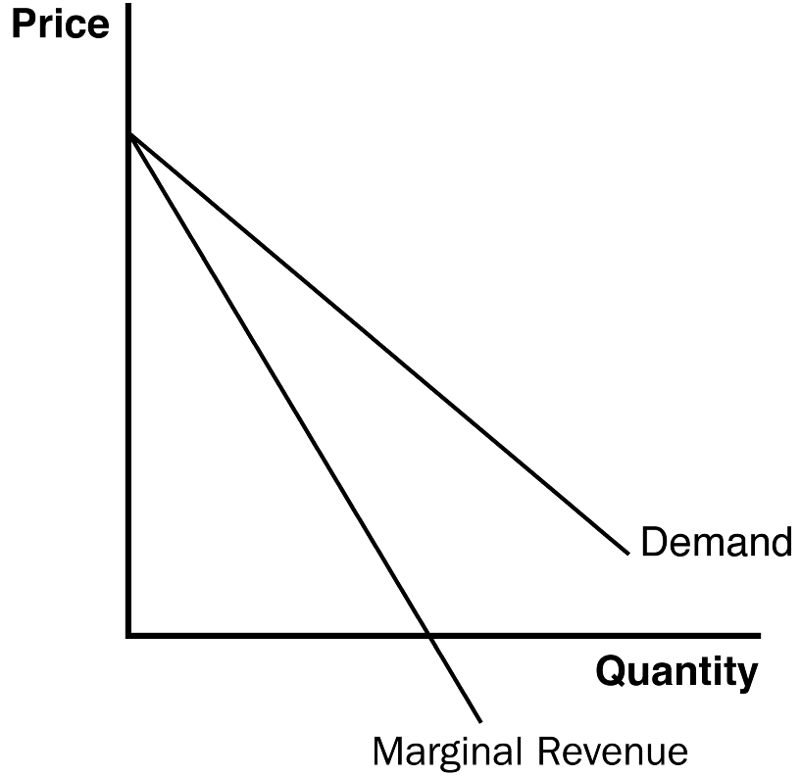
Figure 3

3. When graphing the firm's demand and marginal revenue curve, they always start at the same point (because P = MR for the first unit sold); for every other level of output, marginal revenue lies below the demand curve (because MR < P).

At this point, you may want to discuss the price elasticity of demand again. Remind students that demand tends to be elastic along the upper left-hand portion of the demand curve. Thus, a decrease in price causes total revenue to increase (so that marginal revenue is greater than zero). Further down the demand curve, the demand is inelastic. In this region, a decrease in price results in a drop in total revenue (implying that marginal revenue is now less than zero). Marginal revenue is equal to zero when demand is unit elastic.


C. Profit Maximization

1. The monopolist's profit-maximizing quantity of output occurs where marginal revenue is equal to marginal cost.

a. If marginal revenue is greater than marginal cost, profit can be increased by raising the firm’s level of output.

b. If marginal revenue is less than marginal cost, profit can be increased by lowering the firm’s level of output.

2. Even though MR = MC is the profit-maximizing rule for both competitive firms and monopolies, there is one important difference.

a. In competitive firms, P = MR; at the profit-maximizing level of output, P = MC.

b. In a monopoly, P > MR; at the profit-maximizing level of output, P > MC.

3. The monopolist's price is determined by the demand curve (which shows us how much buyers are willing to pay for the product).

ALTERNATIVE CLASSROOM EXAMPLE:
The costs for the Whatsa Widget Company can be represented by the following schedule:

Quantity | Total Cost | Marginal Cost
0 | $8 | ----
1 | 11 | $3
2 | 16 | 5
3 | 26 | 10
4 | 39 | 13
5 | 57 | 18

Using the earlier information regarding the demand for widgets, have the students find the profit-maximizing level of output (where marginal revenue is equal to marginal cost). Use the information on total revenue and total cost to calculate the level of maximum profit.

Figure 4

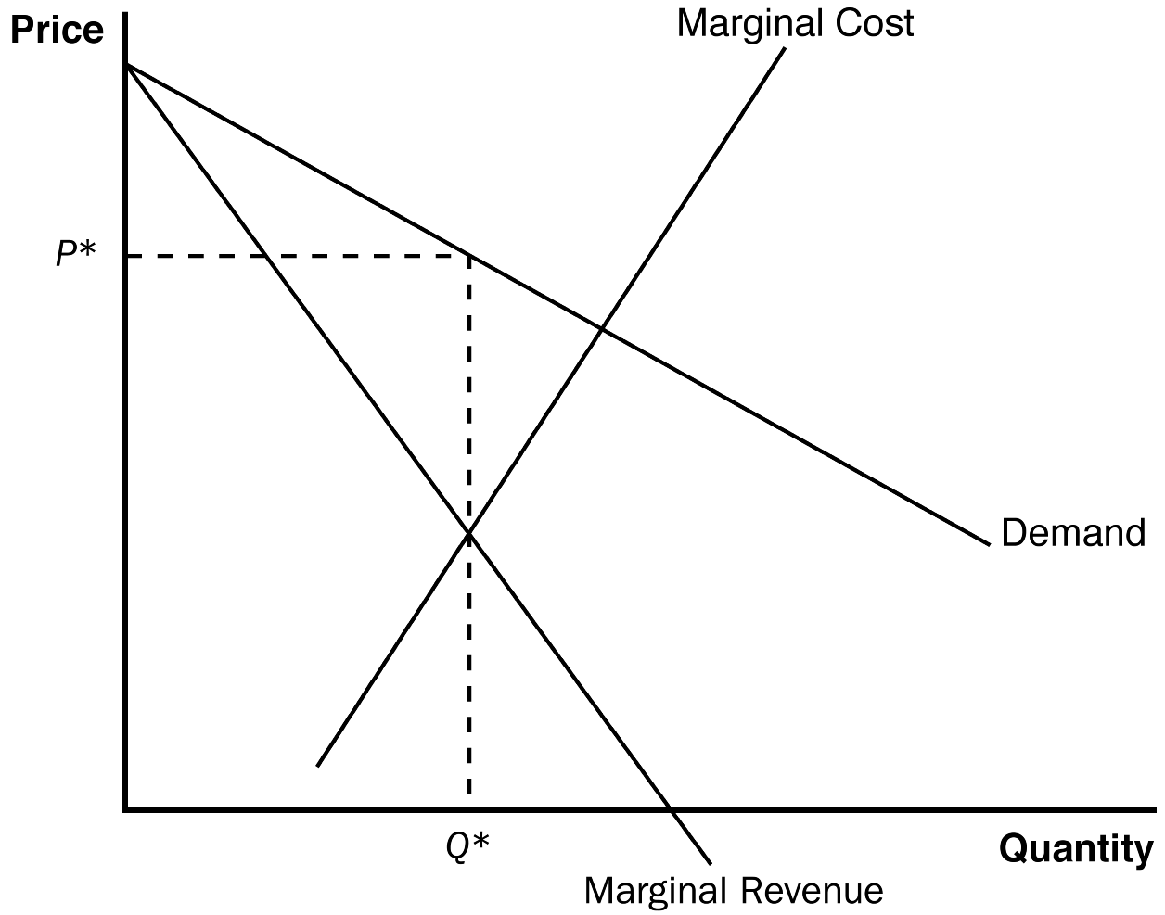

After having seen profit-maximization for a perfectly competitive firm, students generally do not have difficulty understanding that a monopolist will maximize profit where marginal revenue equals marginal cost. However, students do have trouble remembering to use the demand curve to find the monopolist’s price. Be careful to review this point several times.

D. FYI: Why a Monopoly Does Not Have a Supply Curve

1. A supply curve tells us the quantity that a firm chooses to supply at any given price.

2. But a monopoly firm is a price maker; the firm sets the price at the same time it chooses the quantity to supply.

3. It is the market demand curve that tells us how much the monopolist will supply because the shape of the demand curve determines the shape of the marginal revenue curve (which in turn determines the profit-maximizing level of output).

E. A Monopoly's Profit

1. We can find profit using the following equation:

Profit = TR – TC.

2. Because TR = P × Q and TC = ATC × Q, we can rewrite this equation:

Profit = (P – ATC) × Q.

Figure 5
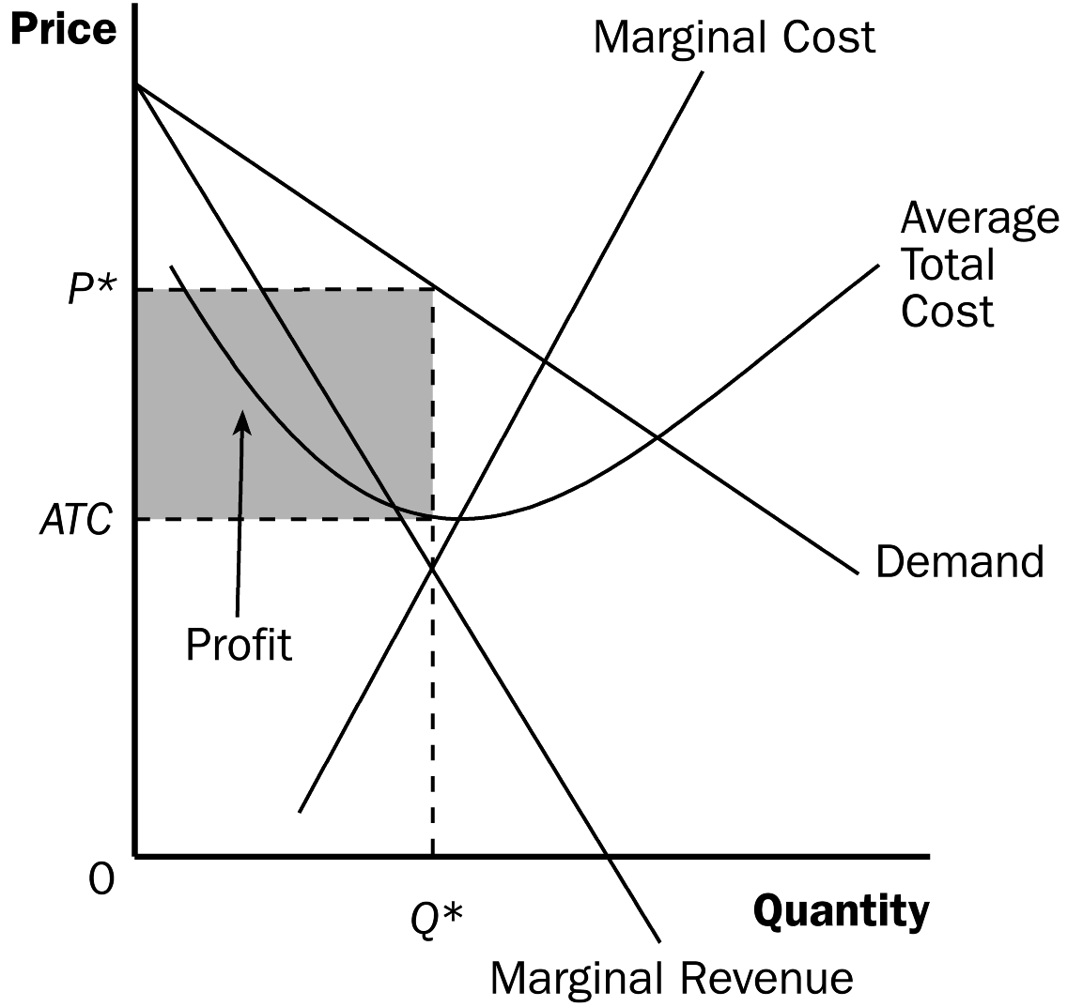

F. Case Study: Monopoly Drugs versus Generic Drugs
Figure 6

1. The market for pharmaceutical drugs takes on both monopoly characteristics and competitive characteristics.
2. When a firm discovers a new drug, patent laws give the firm a monopoly on the sale of that drug. However, the patent eventually expires and any firm can make the drug, which causes the market to become competitive.

3. Analysis of the pharmaceutical industry has shown us that prices of drugs fall after patents expire and new firms begin production of that drug.

IV. The Welfare Cost of Monopolies

A. The Deadweight Loss
Figure 7

1. The demand curve represents the value that buyers place on each additional unit of a good or service. The marginal-cost curve represents the additional cost of producing each unit of a good or service.

2. The socially efficient quantity of output is found where the demand curve and the marginal cost curve intersect. This is where total surplus is maximized.
Remind students that total surplus is the area between the demand curve and the marginal cost curve. It should be clear that surplus is not realized for quantities of output between the monopoly output and the socially efficient output.

3. Because the monopolist sets marginal revenue equal to marginal cost to determine its output level, it will produce less than the socially efficient quantity of output.

4. The price that a monopolist charges is also above marginal cost. Although some potential customers value the good at more than its marginal cost but less than the monopolist’s price, they do not purchase the good even though that is inefficient because total surplus is not maximized.
Figure 8

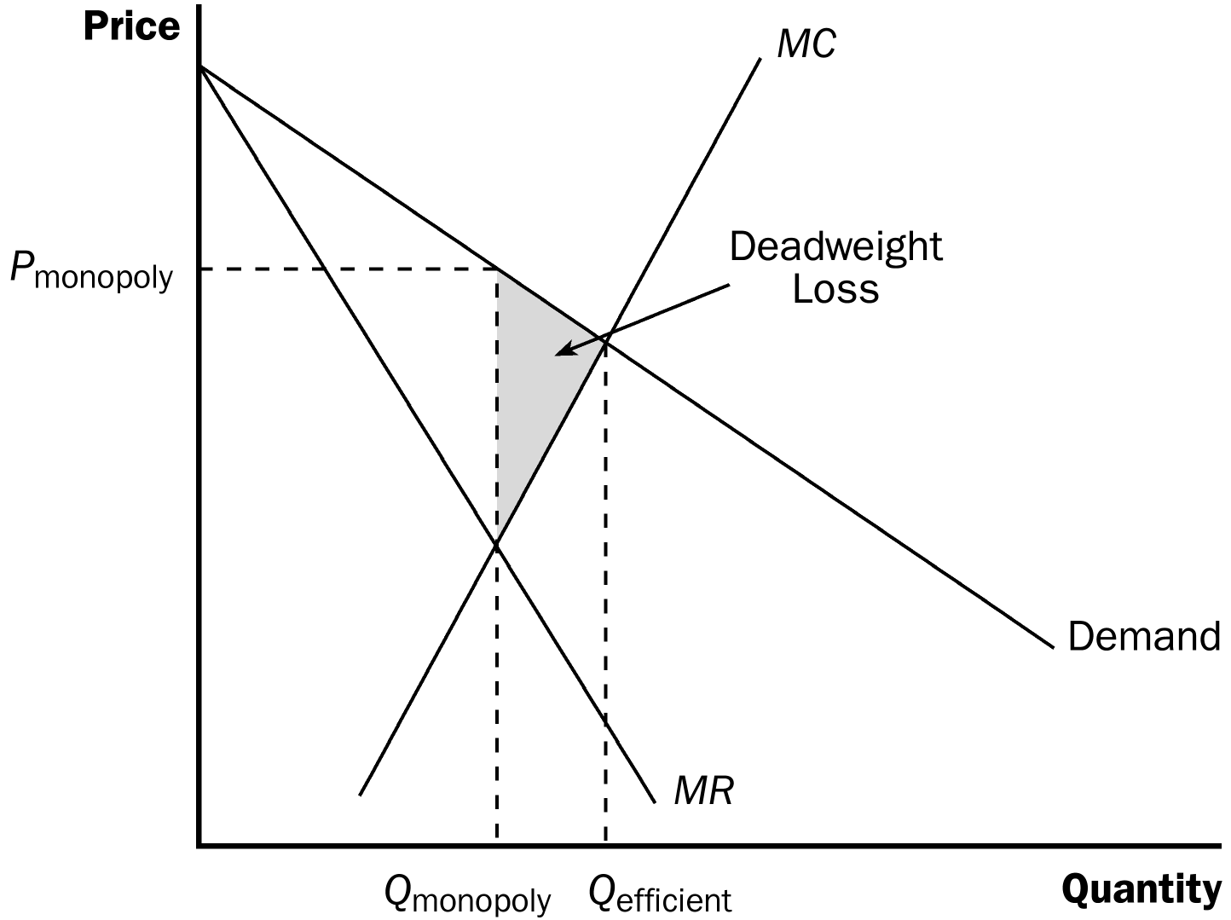

5. The deadweight loss can be seen on the graph as the area between the demand and marginal cost curves for the units between the monopoly quantity and the efficient quantity.
Point out to students that this is similar to the analysis of taxes in Chapter 8. Here, the monopolist places a wedge between price and marginal cost and the quantity sold ends up being short of the optimum level.

B. The Monopoly's Profit: A Social Cost?

1. Welfare in a market includes the welfare of both consumers and producers.

2. The transfer of surplus from consumers to producers is therefore not a social loss.

3. The deadweight loss from monopoly stems from the fact that monopolies produce less than the socially efficient level of output.

4. If the monopoly incurs costs to maintain (or create) its monopoly power, those costs would also be included in deadweight loss.

V. Price Discrimination

A. Definition of price discrimination: the business practice of selling the same good at different prices to different customers.

B. A Parable about Pricing

1. Example: Readalot Publishing Company

2. The firm pays an author $2 million for the right to publish a book. (Assume that the cost of printing the book is zero.)

3. The firm knows that there are two types of readers.

a. There are 100,000 die-hard fans (living in Australia) of the author willing to pay up to $30 for the book.

b. There are 400,000 other readers (living in the United States) who are willing to pay up to $5 for the book.

4. How should the firm set its price?

a. If the firm sets its price equal to $30, it will sell 100,000 copies of the book, receive total revenue of $3 million, and earn $1 million in profit.

b. If the firm sets its price equal to $5, it will sell 500,000 copies, receive total revenue of $2.5 million, and earn only $500,000 in profit.

c. It will choose to set its price at $30 and sell 100,000 books. Note that there is a deadweight loss from this decision because there are 400,000 other customers willing to pay $5, which is more than the marginal cost of producing the book ($0).

5. Since it would be difficult for Australian readers to buy a copy of the book in the United States, the company could make even more profit by selling 100,000 copies to the die-hard fans at $30 each, and then selling 400,000 copies to the other readers for $5 each.

a. The total revenue from selling 100,000 copies at $30 each is $3 million.

b. The total revenue from selling 400,000 copies at $5 each is $2 million.

c. Because the firm's costs are $2 million, profit will be $3 million.

Activity 1—Price Discrimination and Time Travel

Type: In-class demonstration
Topics: Price discrimination, consumer surplus
Materials needed: None
Time: 10 minutes
Class limitations: Works in any size class

Purpose
This example illustrates how a price-discriminating monopolist can earn even higher profits than a monopolist charging a single price. The example uses an imaginary time machine to look at monopoly profits and consumer surplus. The cases of competition, monopoly, and price discriminating monopoly are examined.

Instructions
Use student names in the demand for time travel shown below:
- “Steve” wants to travel back in time to see the dinosaurs; he is willing to pay as much as $200 to use the time machine.
- “Joyce” wants to relive this entire semester; she is willing to pay up to $150 to use the time machine.
- “Chip” can’t wait for the semester to end; he is willing to pay as much as $125 to use the time machine.
- “Dawn” just wants to get through this class period; she is willing to pay up to $100 to use the time machine.

The demand curve for time travel is:

Price Quantity
$200 1
150 2
125 3
100 4

For simplicity, let the marginal cost of time travel be constant at $100. If time travel was a competitive industry, price would equal marginal cost ($100) and 4 trips would be sold.

C. The Moral of the Story

1. By charging different prices to different customers, a monopoly firm can increase its profit.

2. To price discriminate, a firm must be able to separate customers by their willingness to pay.

3. Arbitrage (the process of buying a good in one market at a low price and then selling it in another market at a higher price) will limit a monopolist's ability to price discriminate.

4. Price discrimination can increase economic welfare. Producer surplus rises (because price exceeds marginal cost for all of the units sold) while consumer surplus is unchanged (because price is equal to the consumers’ willingness to pay).
D. The Analytics of Price Discrimination

Figure 9

1. Perfect price discrimination describes a situation where a monopolist knows exactly the willingness to pay of each customer and can charge each customer a different price.

2. Without price discrimination, a firm produces an output level that is lower than the socially efficient level.

3. If a firm perfectly price discriminates, each customer who values the good at more than its marginal cost will purchase the good and be charged his or her willingness to pay.

a. There is no deadweight loss in this situation.

b. Because consumers pay a price exactly equal to their willingness to pay, all surplus in this market will be producer surplus.

E. Examples of Price Discrimination

1. Movie Tickets

2. Airline Prices

3. Discount Coupons

4. Financial Aid

5. Quantity Discounts

F. In the News: Price Discrimination in Higher Education

1. While there is a common belief that the cost of a college education has risen sharply in recent years, the real price has risen for high income families and fallen for low income families.

2. This article from Bloomberg.com describes the price discrimination that occurs in this market.

VI. Public Policy toward Monopolies

A. Increasing Competition with Antitrust Laws

1. Antitrust laws are a collection of statutes that give the government the authority to control markets and promote competition.

a. The Sherman Antitrust Act was passed in 1890 to lower the market power of the large and powerful "trusts” that were viewed as dominating the economy at that time.

b. The Clayton Act was passed in 1914; it strengthened the government's ability to curb monopoly power and authorized private lawsuits.

2. Antitrust laws allow the government to prevent mergers and break up large, dominating companies.

3. Antitrust laws also impose costs on society. Some mergers may provide synergies, which occur when the costs of operations fall because of joint operations.

B. Regulation

1. Regulation is often used when the government is dealing with a natural monopoly.
Local phone and electric companies are good examples of regulated monopoly firms.

2. Most often, regulation involves government limits on the price of the product.

3. While we might believe that the government can eliminate the deadweight loss from monopoly by setting the monopolist's price equal to its marginal cost, this is often difficult to do.
Figure 10

a. If the firm is a natural monopoly, its average total cost curve will be declining because of its economies of scale.

b. When average total cost is falling, marginal cost must be lower than average total cost.

c. Therefore, if the government sets price equal to marginal cost, the price will be below average total cost and the firm will earn a loss, causing the firm to eventually leave the market.

4. Therefore, governments may choose to set the price of the monopolist's product equal to its average total cost. This gives the monopoly zero profit, but assures that it will remain in the market.

a. There is still a deadweight loss in this situation because the level of output will be lower than the socially efficient level of output.

b. Average-cost pricing also provides no incentive for the monopolist to reduce costs.

C. Public Ownership

1. Rather than regulating a monopoly run by a private firm, the government can run the monopoly itself.

2. However, economists generally prefer private ownership of natural monopolies.

a. Private owners have an incentive to keep costs down to earn higher profits.

b. If government bureaucrats do a bad job running a monopoly, the political system is the taxpayers’ only recourse.

D. Doing Nothing

1. Sometimes the costs of government regulation outweigh the benefits.

2. Therefore, some economists believe that it is best for the government to leave monopolies alone.

VII. Conclusion: The Prevalence of Monopolies
Table 2

A. Monopoly firms behave very differently from competitive firms.

B. Table 2 summarizes the key similarities and differences between monopoly and competitive markets.

SOLUTIONS TO TEXT PROBLEMS:

Quick Quizzes

1. A market might have a monopoly because: (1) a key resource is owned by a single firm; (2) the government gives a single firm the exclusive right to produce some good; or (3) the costs of production make a single producer more efficient than a large number of producers.

Examples of monopolies include: (1) the water producer in a small town, who owns a key resource, the one well in town; (2) a pharmaceutical company that is given a patent on a new drug by the government; and (3) a bridge, which is a natural monopoly because (if the bridge is uncongested) having just one bridge is efficient. Many other examples are possible.

2. A monopolist chooses the amount of output to produce by finding the quantity at which marginal revenue equals marginal cost. It finds the price to charge by finding the point on the demand curve that corresponds to that quantity. The monopolist wants to charge the highest possible price but still sell his profit-maximizing level of output.

3. A monopolist produces a quantity of output that is less than the quantity of output that maximizes total surplus because it produces the quantity at which marginal cost equals marginal revenue rather than the quantity at which marginal cost equals price. This lower production level leads to a deadweight loss.

4. Examples of price discrimination include: (1) movie tickets, for which children and senior citizens get lower prices; (2) airline prices, which are different for business and leisure travelers; (3) discount coupons, which lead to different prices for people who value their time in different ways; (4) financial aid, which offers college tuition at lower prices to poor students and higher prices to wealthy students; and (5) quantity discounts, which offer lower prices for higher quantities, capturing more of a buyer’s willingness to pay. Many other examples are possible.

Compared to a monopoly that charges a single price, perfect price discrimination reduces consumer surplus to zero, increases producer surplus, and increases total surplus because there is no deadweight loss.

5. Policymakers can respond to the inefficiencies caused by monopolies in one of four ways: (1) by trying to make monopolized industries more competitive; (2) by regulating the behavior of the monopolies; (3) by turning some private monopolies into public enterprises; or (4) by doing nothing at all. Antitrust laws prohibit mergers of large companies and prevent large companies from coordinating their activities in ways that make markets less competitive, but such laws may keep companies from merging and generating synergies that increase efficiency. Some monopolies, especially natural monopolies, are regulated by the government, but it is hard to keep a monopoly in business, achieve marginal-cost pricing, and give the monopolist an incentive to reduce costs. Private monopolies can be taken over by the government, but the companies are not likely to be well-run. Sometimes doing nothing at all may seem to be the best solution, but there are clearly deadweight losses from monopoly that society will have to bear.

Questions for Review

1. Government-created monopoly comes from the existence of patent and copyright laws. Both allow firms or individuals to be monopolies for extended periods of time—20 years for patents, the life of the author plus 70 years for copyrights. But this monopoly power is good, because without it, no one would write a book or a song and no firm would invest in research and development to invent new products or pharmaceuticals.

2. An industry is a natural monopoly when a single firm can supply a good or service to an entire market at a smaller cost than could two or more firms. As a market grows, it may evolve from a natural monopoly to a competitive market.

3. A monopolist's marginal revenue is less than the price of its product because its demand curve is the market demand curve. Thus, to increase the amount sold, the monopolist must lower the price of its good for every unit it sells. This cut in price reduces the revenue on the units it was already selling.

A monopolist's marginal revenue can be negative because to get purchasers to buy an additional unit of the good, the firm must reduce its price on all units of the good. The fact that it sells a greater quantity increases the firm’s revenue, but the decline in price decreases the firm’s revenue. The overall effect depends on the price elasticity of demand. If demand is inelastic, marginal revenue will be negative.

4. Figure 1 shows the demand, marginal-revenue, average-total-cost, and marginal-cost curves for a monopolist. The intersection of the marginal-revenue and marginal-cost curves determines the profit-maximizing level of output, Q_{m}. The profit-maximizing price, P_{m} can be found using the demand curve. Profit is shown as the rectangular area with a height of (P_{M} – ATC_{M}) and a base of Q_{M}.

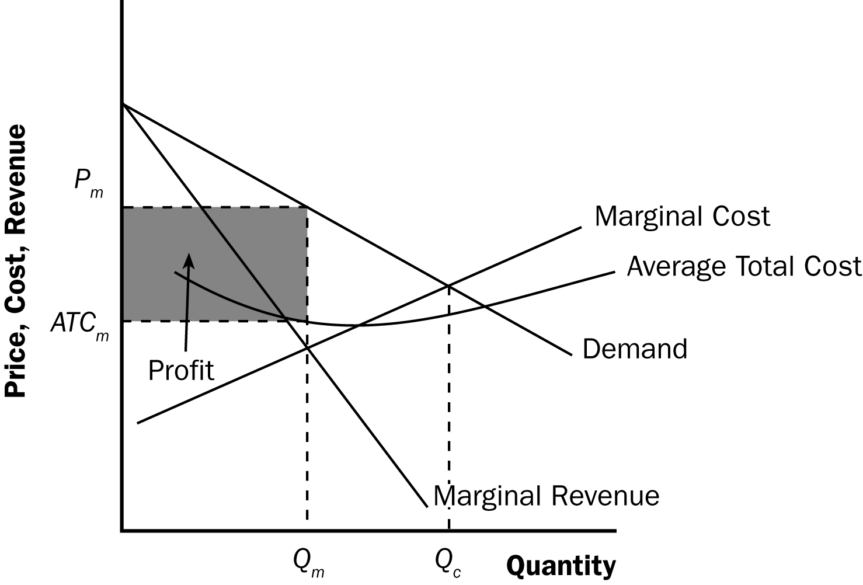

Figure 1

5. The level of output that maximizes total surplus in Figure 1 is where the demand curve intersects the marginal-cost curve, Q_{c}. The deadweight loss from monopoly is the triangular area between Q_{c} and Q_{m} that is above the marginal-cost curve and below the demand curve. It represents deadweight loss, because society loses total surplus because of the monopoly. The deadweight loss is equal to the value of the good (measured by the height of the demand curve) less the cost of production (given by the height of the marginal-cost curve), for the quantities between Q_{m} and Q_{c}.

6. One example of price discrimination is in publishing books. Publishers charge a much higher price for hardback books than for paperback books—far higher than the difference in production costs. Publishers do this because die-hard fans will pay more for a hardback book when the book is first released. Those who don't value the book as highly will wait for the paperback version to come out. The publisher makes a greater profit this way than if it charged just one price.

A second example is the pricing of movie tickets. Theaters give discounts to children and senior citizens because they have a lower willingness to pay for a ticket. Charging different prices helps the theater increase its profit above what it would be if it charged just one price.

Many other examples are possible.

7. The government has the power to regulate mergers between firms because of antitrust laws. Firms might want to merge to increase operating efficiency and reduce costs, something that is good for society, or to gain market power, which is bad for society.

8. When regulators tell a natural monopoly that it must set price equal to marginal cost, two problems arise. The first is that, because a natural monopoly has a marginal cost that is always less than average total cost, setting price equal to marginal cost means that the firm will incur a loss. The firm would then exit the industry unless the government subsidized it. However, getting revenue for such a subsidy would cause the government to raise other taxes, increasing the deadweight loss. The second problem of using costs to set price is that it gives the monopoly no incentive to reduce costs.

Quick Check Multiple Choice

1. d

2. b

3. d

4. a

5. b

6. c

Problems and Applications

1. The following table shows revenue, costs, and profits:

Price | Quantity | Total Revenue | Marginal Revenue | Total Cost | Profit
$100 | 0 | $0 | ---- | $2,000,000 | $-2,000,000
90 | 100,000 | 9,000,000 | $90 | 3,000,000 | 6,000,000
80 | 200,000 | 16,000,000 | 70 | 4,000,000 | 12,000,000
70 | 300,000 | 21,000,000 | 50 | 5,000,000 | 16,000,000
60 | 400,000 | 24,000,000 | 30 | 6,000,000 | 18,000,000
50 | 500,000 | 25,000,000 | 10 | 7,000,000 | 18,000,000
40 | 600,000 | 24,000,000 | -10 | 8,000,000 | 16,000,000
30 | 700,000 | 21,000,000 | -30 | 9,000,000 | 12,000,000
20 | 800,000 | 16,000,000 | -50 | 10,000,000 | 6,000,000
10 | 900,000 | 9,000,000 | -70 | 11,000,000 | -2,000,000
0 | 1,000,000 | 0 | -90 | 12,000,000 | -12,000,000

a. A profit-maximizing publisher would choose a quantity of 400,000 at a price of $60 or a quantity of 500,000 at a price of $50; both combinations would lead to profits of $18 million.

b. Marginal revenue is less than price. Price falls when quantity rises because the demand curve slopes downward, but marginal revenue falls even more than price because the firm loses revenue on all the units of the good sold when it lowers the price.

c. Figure 2 shows the marginal-revenue, marginal-cost, and demand curves. The marginal-revenue and marginal-cost curves cross between quantities of 400,000 and 500,000. This signifies that the firm maximizes profits in that region.

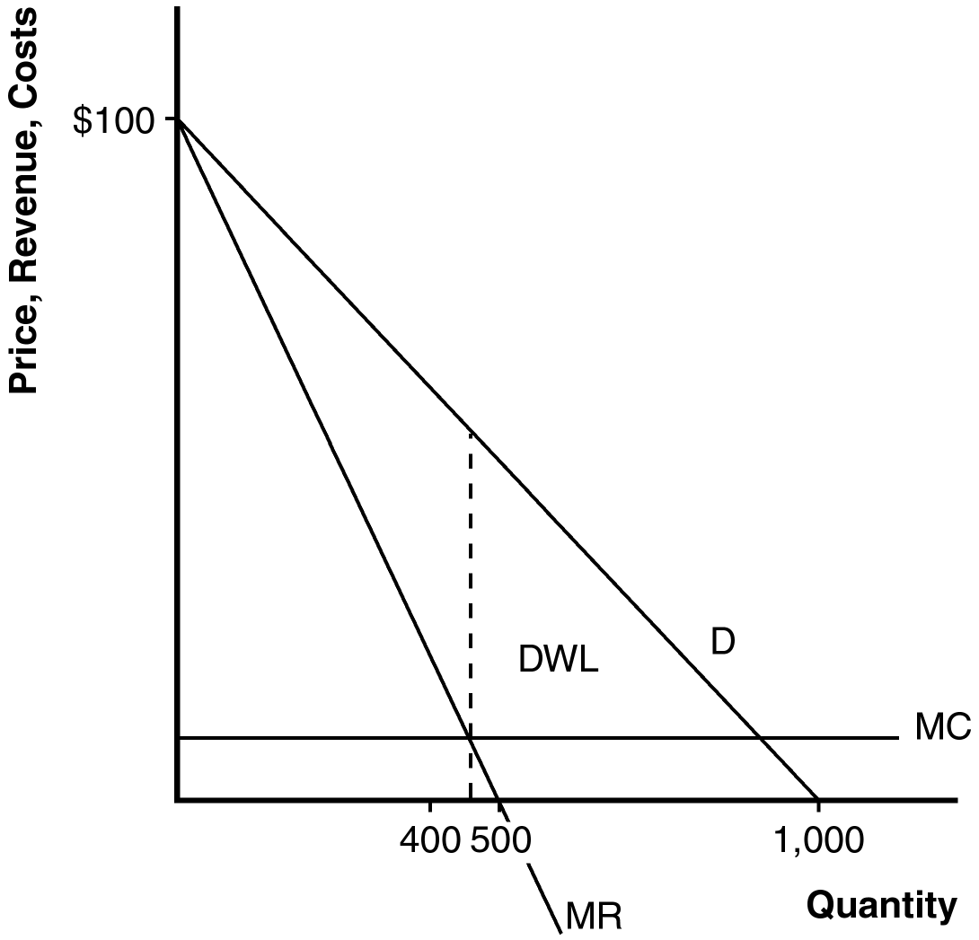

Figure 2

d. The area of deadweight loss is marked “DWL” in the figure. Deadweight loss means that the total surplus in the economy is less than it would be if the market were competitive, because the monopolist produces less than the socially efficient level of output.

e. If the author were paid $3 million instead of $2 million, the publisher would not change the price, because there would be no change in marginal cost or marginal revenue. The only thing that would be affected would be the firm’s profit, which would fall.

f. To maximize economic efficiency, the publisher would set the price at $10 per book, because that is the marginal cost of the book. At that price, the publisher would have negative profits equal to the amount paid to the author.

2. a. Figure 3 illustrates the market for groceries when there are many competing supermarkets with constant marginal cost. Output is Q_{C}, price is P_{C}, consumer surplus is area A, producer surplus is zero, and total surplus is area A.

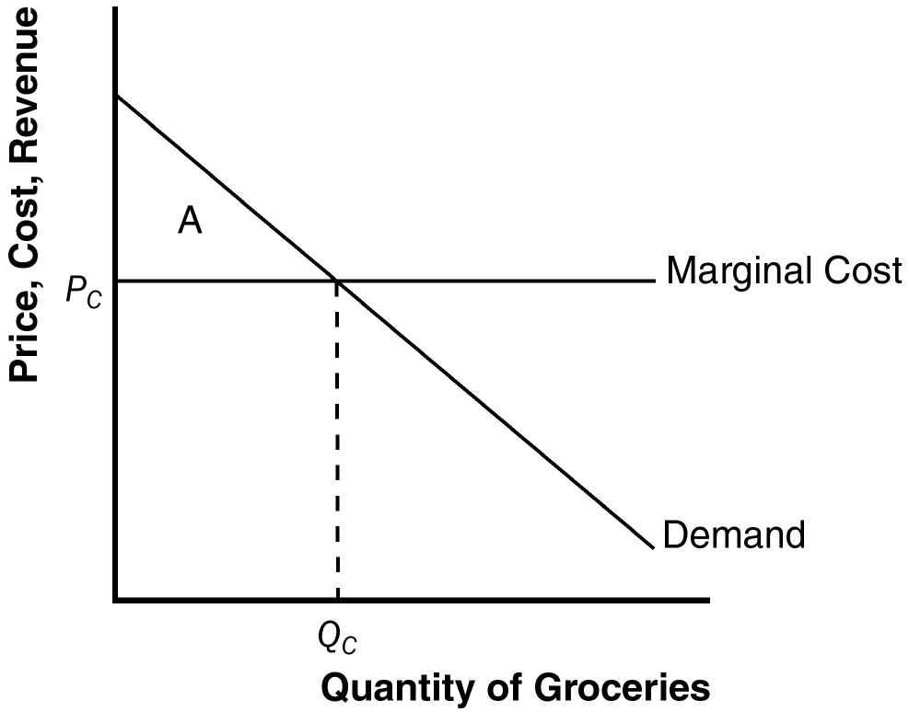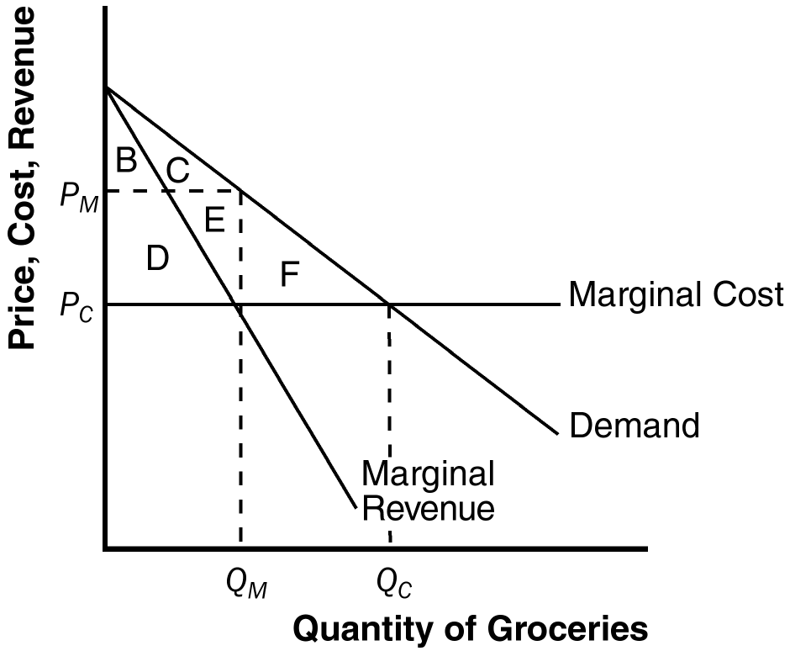

Figure 3 Figure 4

b. Figure 4 illustrates the new situation when the supermarkets merge. Quantity declines from Q_{C} to Q_{M} and price rises to P_{M}. Consumer surplus falls by areas D + E + F to areas B + C. Producer surplus becomes areas D + E, and total surplus is areas B + C + D + E. Consumers transfer the amount of areas D + E to producers and the deadweight loss is area F.

3. a. The following table shows total revenue and marginal revenue for each price and quantity sold:

Price | Quantity | Total Revenue | Marginal Revenue | Total Cost | Profit
24 | 10,000 | $240,000 | ---- | $50,000 | $190,000
22 | 20,000 | 440,000 | $20 | 100,000 | 340,000
20 | 30,000 | 600,000 | 16 | 150,000 | 450,000
18 | 40,000 | 720,000 | 12 | 200,000 | 520,000
16 | 50,000 | 800,000 | 8 | 250,000 | 550,000
14 | 60,000 | 840,000 | 4 | 300,000 | 540,000

b. Profits are maximized at a quantity where MR=MC. The quantity at which MC is closest to MR without exceeding it is 50,000 CDs at a price of $16. At that point, profit is $550,000.

c. As Johnny's agent, you should recommend that he demand $550,000 from them, so he receives all of the profit (rather than the record company). The firm would still choose to produce 50,000 CDs because their marginal cost would not change.

4. a. The table below shows total revenue and marginal revenue for the bridge. The profit-maximizing price will occur at the quantity at which marginal revenue equals marginal cost. In this case marginal cost equals zero, so the profit-maximizing quantity occurs where marginal revenue equals 0. This occurs at a price of $4 and quantity of 400,000 crossings. The efficient level of output is 800,000 crossings, because that is where price is equal to marginal cost. The profit-maximizing quantity is lower than the efficient quantity because the firm is a monopolist.

Price | Quantity  (in Thousands) | Total Revenue  (in Thousands) | Marginal Revenue
$8 | 0 | $0 | ----
7 | 100 | 700 | $7
6 | 200 | 1,200 | 5
5 | 300 | 1,500 | 3
4 | 400 | 1,600 | 1
3 | 500 | 1,500 | -1
2 | 600 | 1,200 | -3
1 | 700 | 700 | -5
0 | 800 | 0 | -7

b. The company should not build the bridge because its profits are negative. The most revenue it can earn is $1,600,000 and the cost is $2,000,000, so it would lose $400,000.

c. If the government were to build the bridge, it should set price equal to marginal cost to be efficient. Since marginal cost is zero, the government should not charge people to use the bridge.
Price
$8

Area
= 1/2 x 8 x 800,000
= $3,200,000
Demand

800,000
Quantity of Crossings

Figure 5

d. Yes, the government should build the bridge, because it would increase society's total surplus. As shown in Figure 5, total surplus has area ½ × 8 × 800,000 = $3,200,000, which exceeds the cost of building the bridge.

5. Larry wants to sell as many drinks as possible without losing money, so he wants to set quantity where price (demand) equals average total cost, which occurs at quantity Q_{L} and price P_{L} in Figure 6. Curly wants to bring in as much revenue as possible, which occurs where marginal revenue equals zero, at quantity Q_{C} and price P_{C}. Moe wants to maximize profits, which occurs where marginal cost equals marginal revenue, at quantity Q_{M} and price P_{M}.

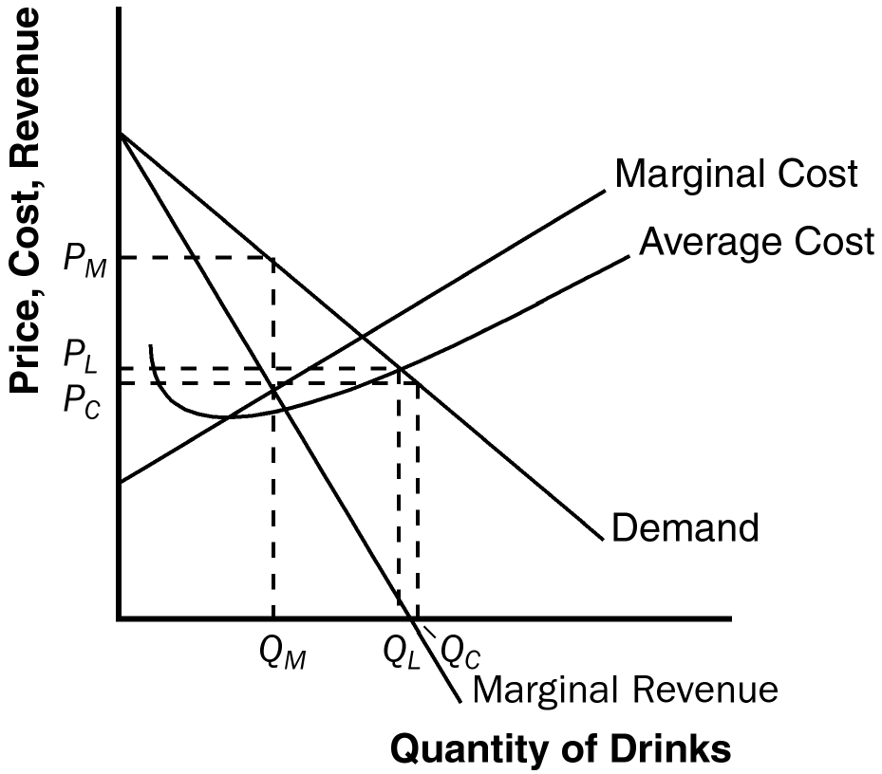

Figure 6

6. a. Figure 7 shows the firm’s average-total-cost curve and marginal-cost curve. (The marginal-cost curve is a horizontal line at $0 because there are no variable costs.) Because average total cost falls continuously as output rises, this firm is a natural monopoly.

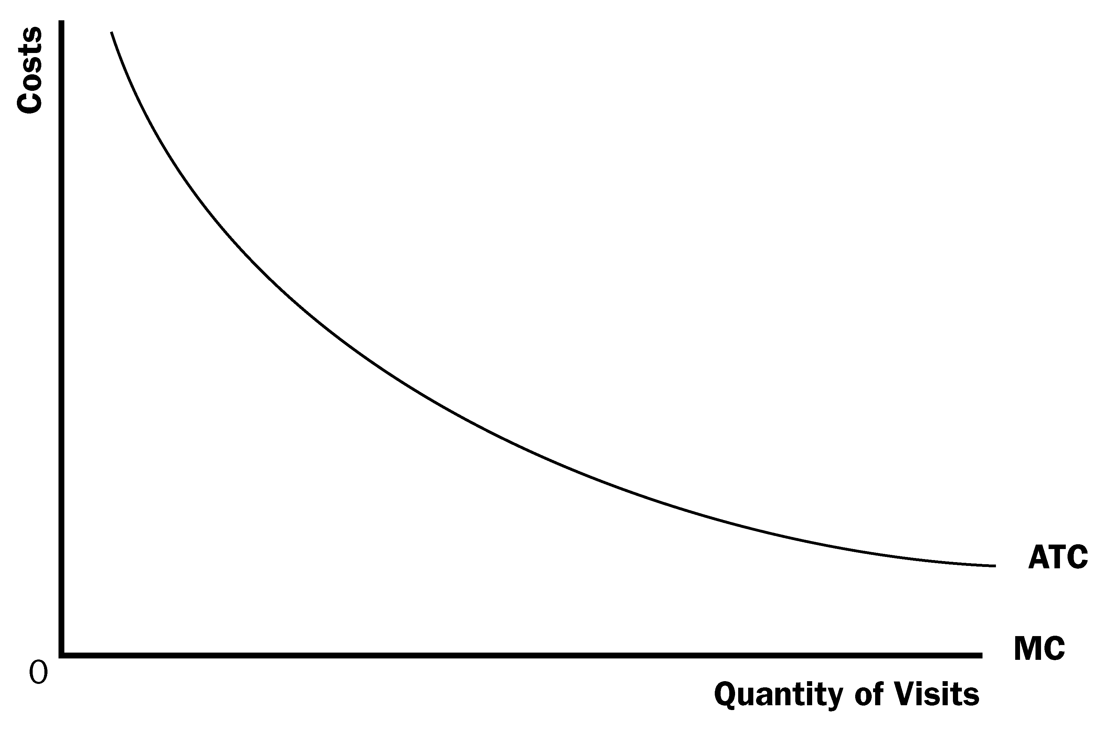
Figure 7

b. If price is equal to $0, each person would visit the museum 10 times (= 10 – 0). Figure 8 shows the consumer surplus each resident would get. The benefit to each resident would be consumer surplus (½ × 10 × $10 = $50) minus the tax ($24) or $26.

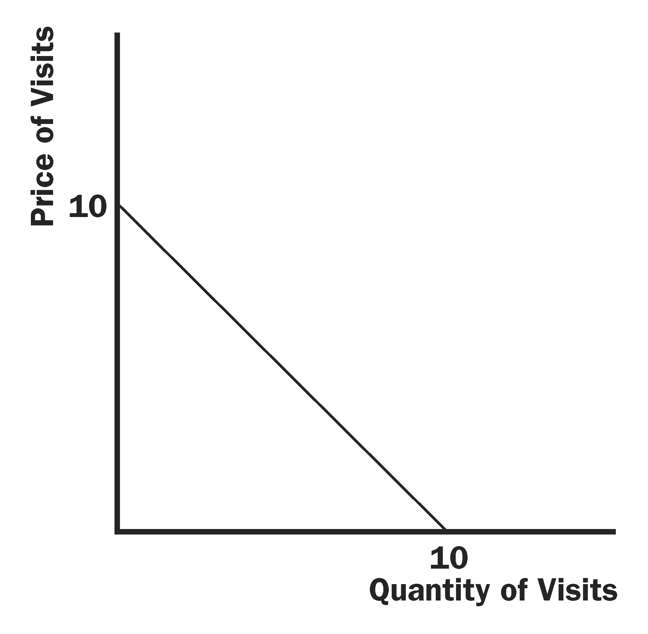
Figure 8

c. The table below shows the total revenue and profit for the town at various prices:

Price | Q^{d} per resident | Total Revenue | Profit
$2 | 8 | 1,600,000 | -800,000
3 | 7 | 2,100,000 | -300,000
4 | 6 | 2,400,000 | 0
5 | 5 | 2,500,000 | 100,000

A price of $4 would allow the town to break even.

d. At a price of $4, each consumer would earn consumer surplus equal to ½ × 6 × 6 = $18. (See Figure 9.) Consumers would be worse off. The town would gain revenue of $24 per person, but it would not offset the drop in consumer surplus. Therefore, there would be a deadweight loss.

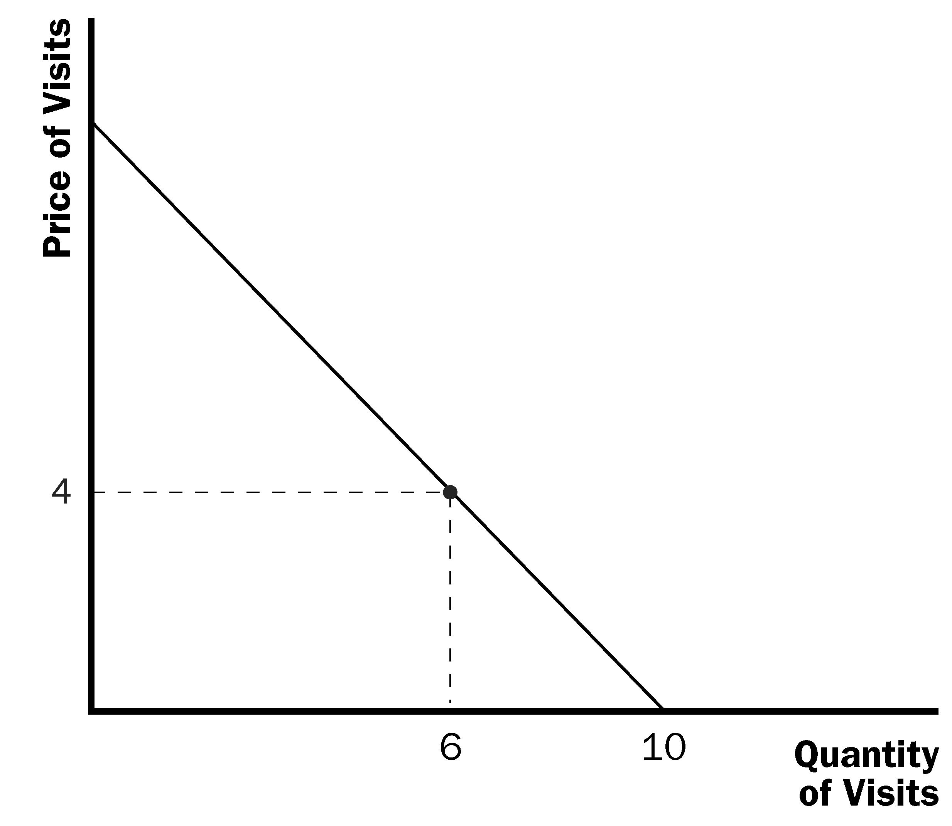
Figure 9

e. In the real world, it is unlikely that all residents have the same demand. Thus, an admission price would push more of the cost on those who would use the museum.

7. a. A monopolist always produces a quantity at which demand is elastic. If the firm produced a quantity for which demand was inelastic and the firm raised its price, quantity would fall by a smaller percentage than the rise in price, so revenue would increase. Because costs would decrease at a lower quantity, the firm would have higher revenue and lower costs, so profit would be higher. Thus the firm should keep raising its price until profits are maximized, which must happen on an elastic portion of the demand curve.

b. As Figure 10 shows, another way to see this is to note that on an inelastic portion of the demand curve, marginal revenue is negative. Increasing quantity requires a greater percentage reduction in price, so revenue declines. Because a firm maximizes profit where marginal cost equals marginal revenue, and marginal cost is never negative, the profit-maximizing quantity can never occur where marginal revenue is negative. Thus, it can never be on the inelastic portion of the demand curve. Total revenue is maximized where marginal revenue is equal to zero (Q_{TR} on Figure 10).

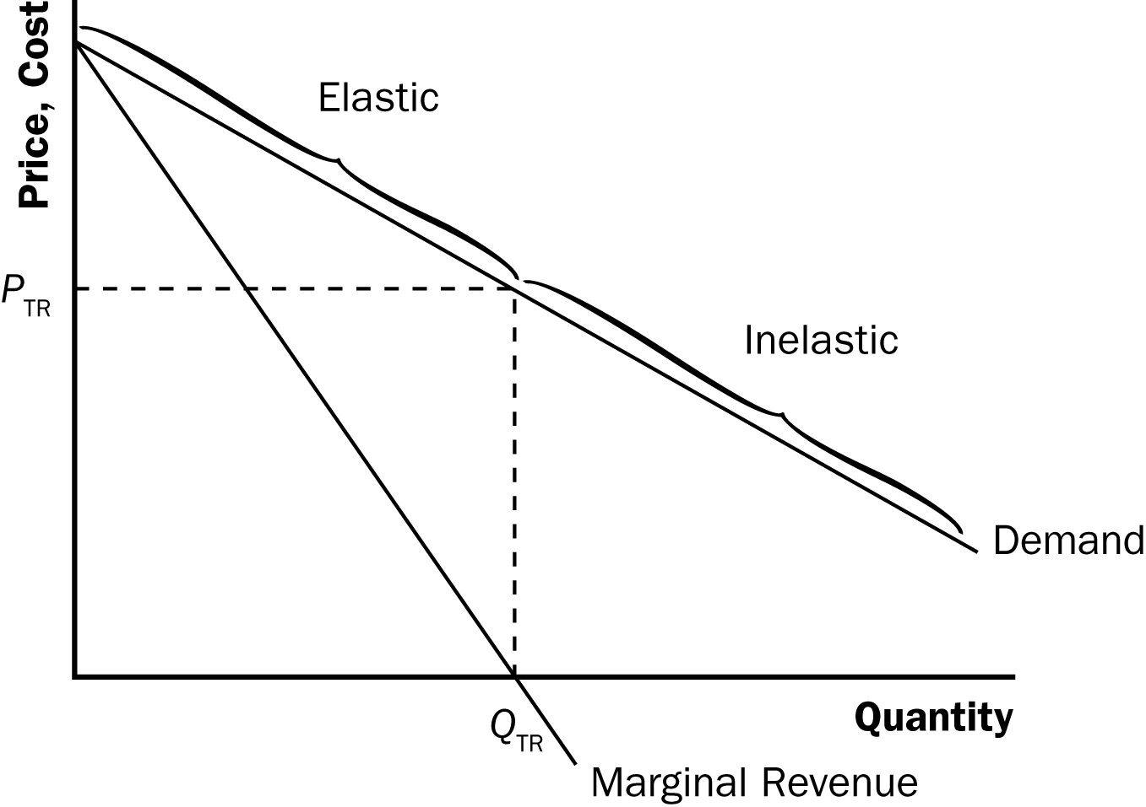

Figure 10

8. a. The profit-maximizing outcome is the same as maximizing total revenue in this case because there are no variable costs. The total revenue from selling to each type of consumer is shown in the following tables:

Price | Quantity of Adult Tickets | Total Revenue from Sale of Adult Tickets
10 | 0 | 0
9 | 100 | 900
8 | 200 | 1,600
7 | 300 | 2,100
6 | 300 | 1,800
5 | 300 | 1,500
4 | 300 | 1,200
3 | 300 | 900
2 | 300 | 600
1 | 300 | 300
0 | 300 | 0

Price | Quantity of Child Tickets | Total Revenue from Sale of Child Tickets
10 | 0 | 0
9 | 0 | 0
8 | 0 | 0
7 | 0 | 0
6 | 0 | 0
5 | 100 | 500
4 | 200 | 800
3 | 200 | 600
2 | 200 | 400
1 | 200 | 200
0 | 200 | 0

To maximize profit, you should charge adults $7 and sell 300 tickets. You should charge children $4 and sell 200 tickets. Total revenue will be $2,100 + $800 = $2,900. Because total cost is $2,000, profit will be $900.

b. If price discrimination were not allowed, you would want to set a price of $7 for the tickets. You would sell 300 tickets and profit would be $100.

c. The children who were willing to pay $4 but will not see the show now that the price is $7 will be worse off. The producer is worse off because profit is lower. Total surplus is lower. There is no one that is better off.

d. In (a) total profit would be $400. In (b), there would be a $400 loss. There would be no change in (c).

9 a. The monopolist would set marginal revenue equal to marginal cost and then substitute the profit-maximizing quantity into the demand curve:

10 – 2Q = 1 + Q
9 = 3Q
Q = 3
P = 10 – Q = $7

Total revenue = P × Q = ($7)(3) = $21
Total cost = 3 + 3 + 0.5(9) = $10.5
Profit = $21 – $10.5 = $10.5

b. The firm becomes a price taker at a price of $6 and no longer has monopoly power. In a competitive equilibrium, the price equals marginal cost so,

10 - Q = 1 + Q
10 = 1 + 2Q
9 = 2Q
Q = 4.5
P = 5.5

The firm will export soccer balls because the world price is greater than the domestic price (in the absence of monopoly power). As Figure 11 shows, domestic production will rise to 5 soccer balls, domestic consumption will rise to 4, and exports will be 1.

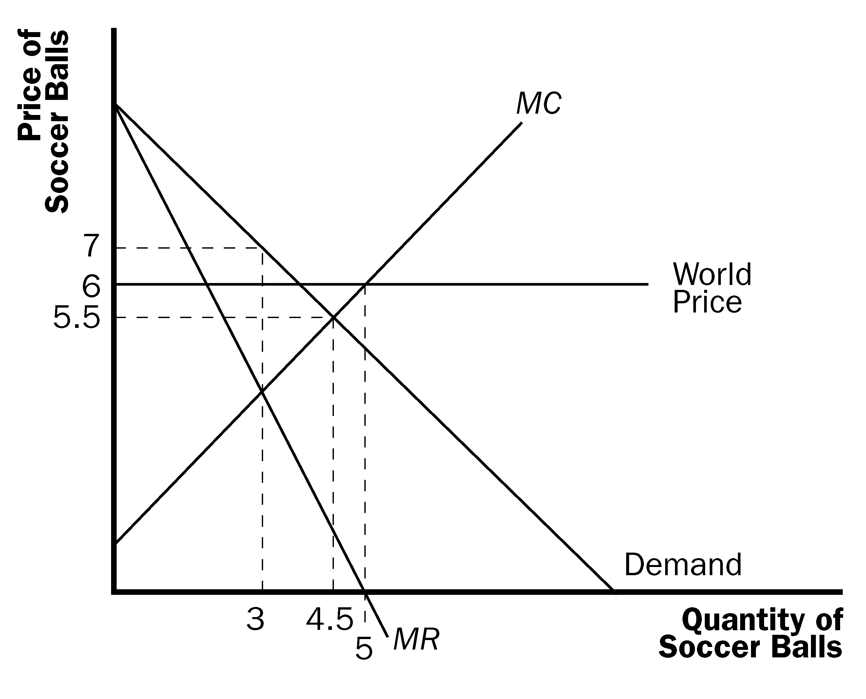
Figure 11

c. The price actually falls even though Wiknam will now export soccer balls. Once trade begins, the firm no longer has monopoly power and must become a price taker. However, the world price of $6 is greater than the competitive equilibrium price ($5.50) so the country exports soccer balls.

d. Yes. The country would still export balls at a world price of $7. The firm is a price taker and no longer is facing a downward-sloping demand curve. Thus, it is now possible to sell more without reducing price.

10. a. Figure 12 shows the firm’s demand, marginal revenue, and marginal cost curves. The firm’s profit is maximized at the output where marginal revenue is equal to marginal cost. Therefore, setting the two equations equal, we get:

1,000 – 20Q = 100 + 10Q
900 = 30Q
Q = 30

The monopoly price is P = 1,000 – 10Q = 700 Ectenian dollars.

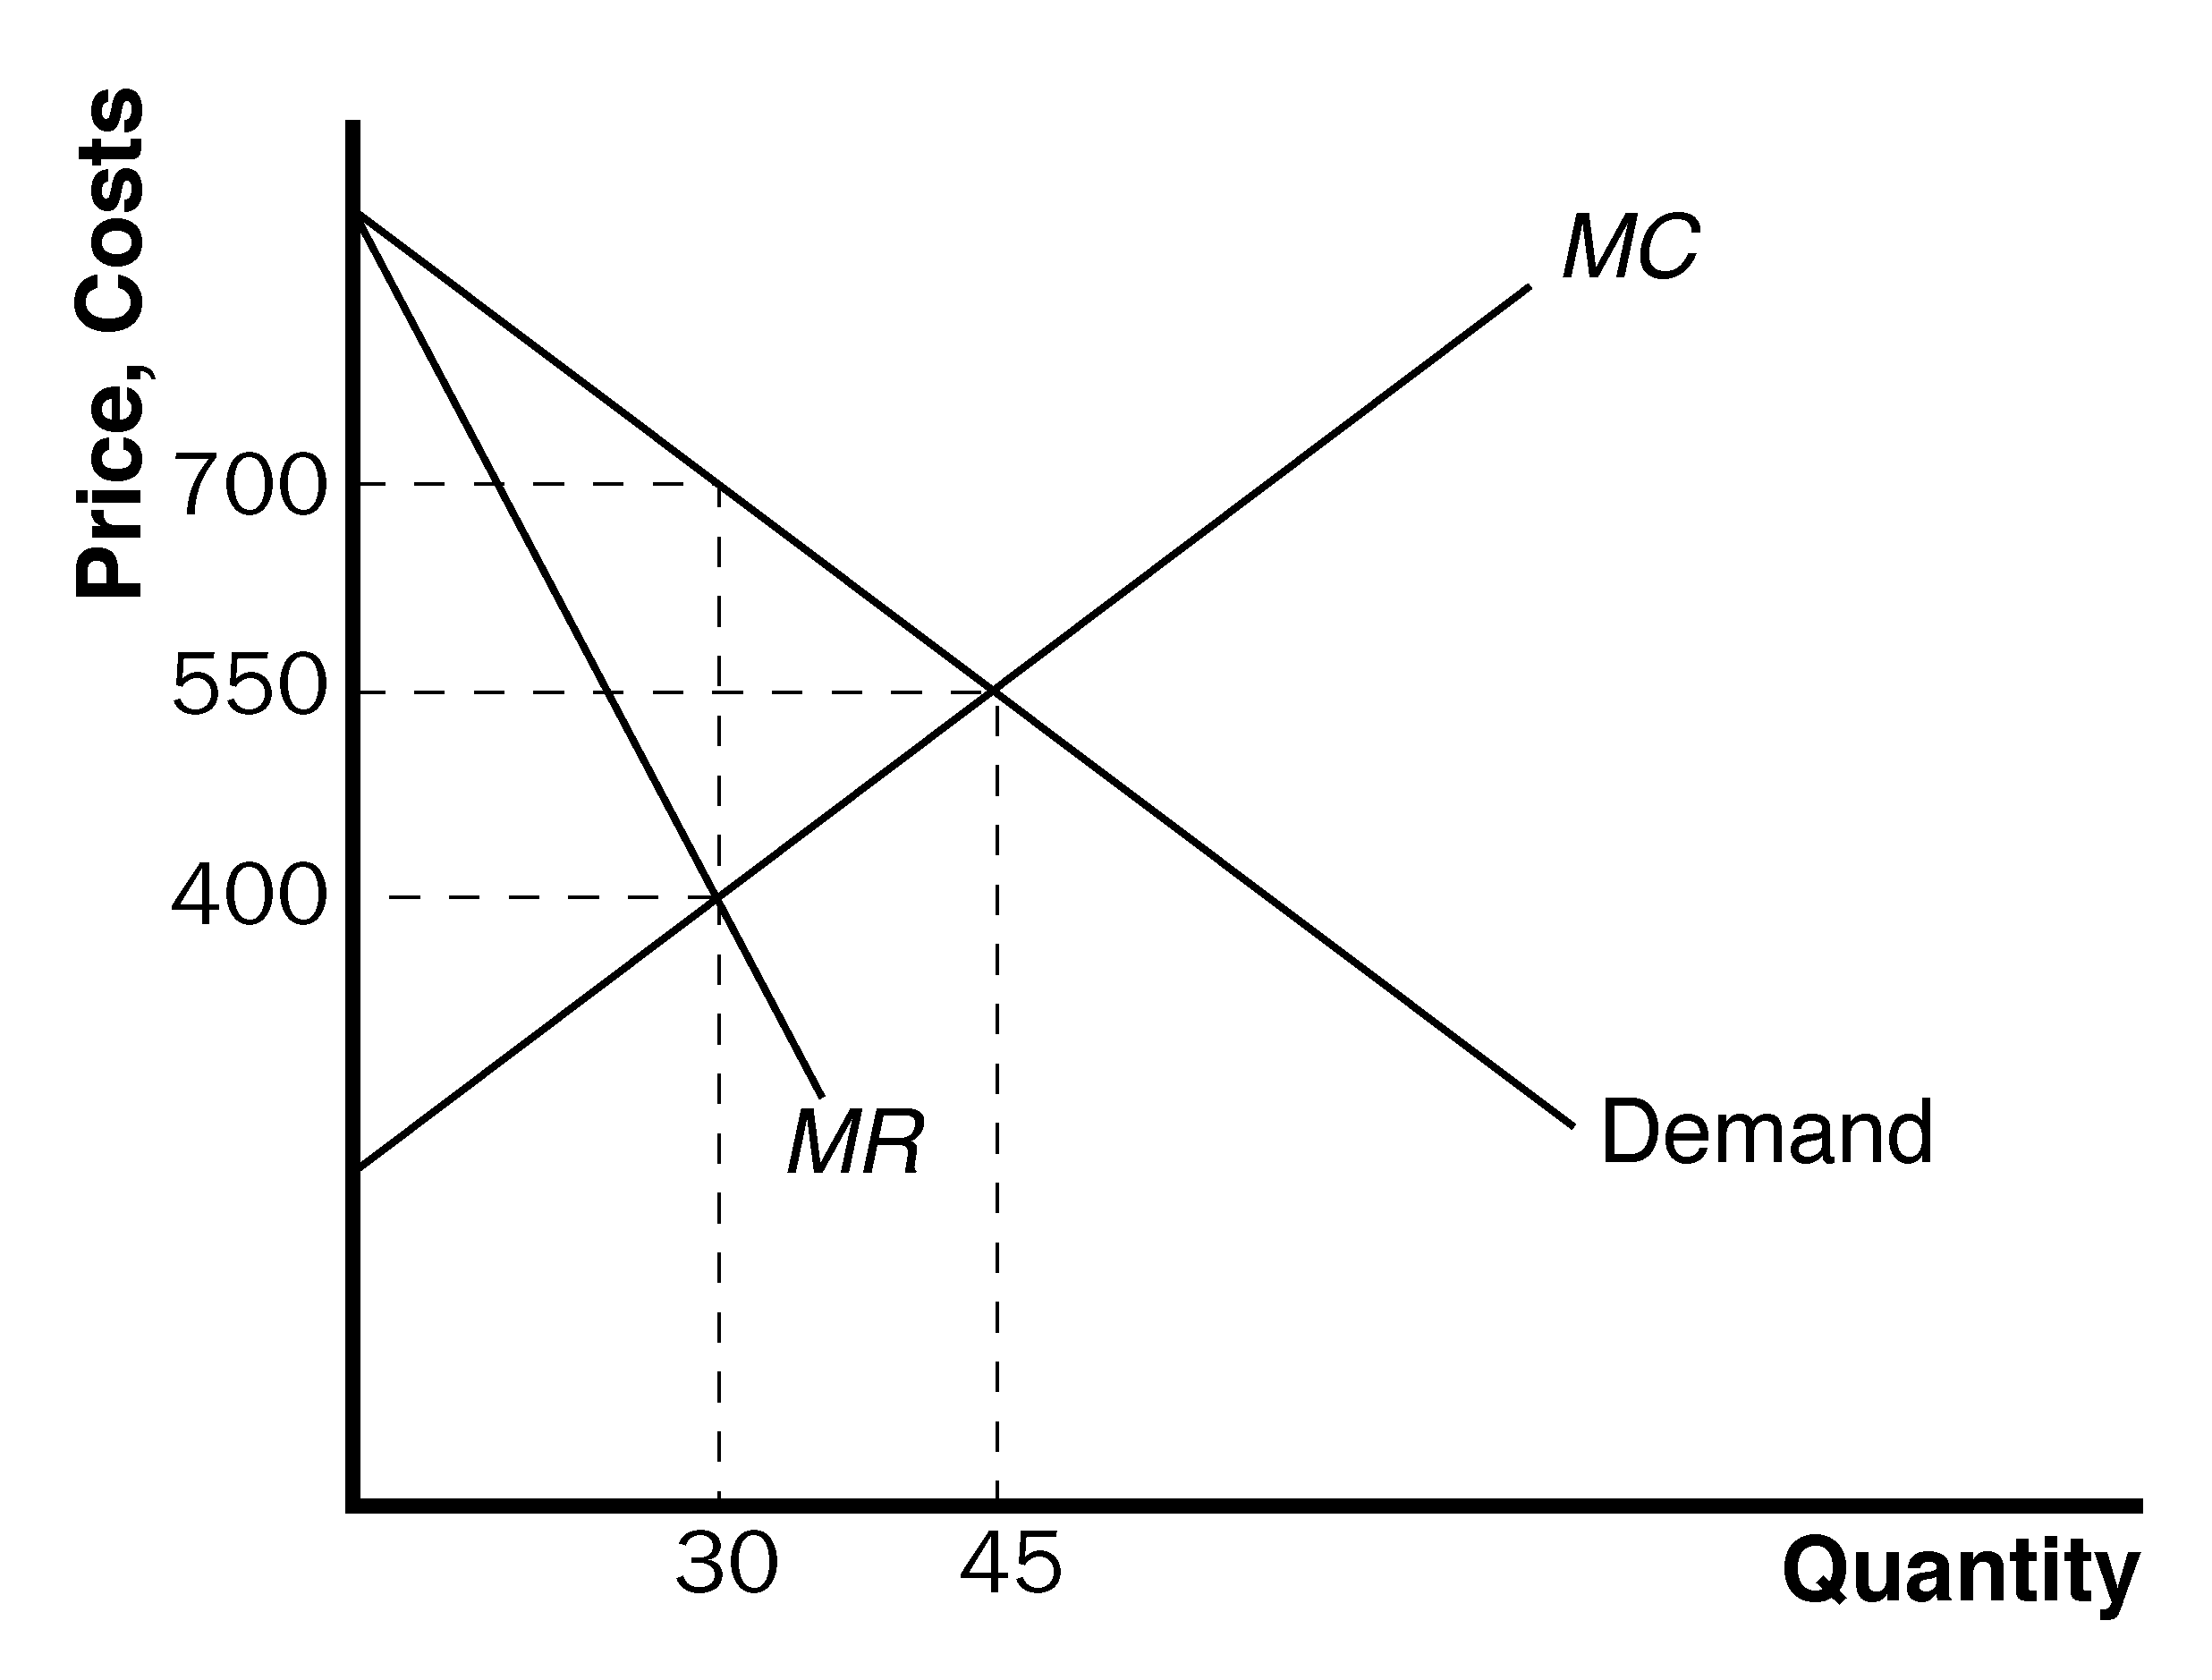

Figure 12

b. Social welfare is maximized where price is equal to marginal cost:

1,000 – 10Q = 100 + 10Q
900 = 20Q
Q = 45

At an output level of 45, the price would be 550 Ectenian dollars.

c. The deadweight loss would be equal to (0.5)(15)(300) = 2,250 Ectenian dollars.

d. i. A flat fee of 2000 Ectenian dollars would not alter the profit-maximizing price or quantity. The deadweight loss would be unaffected.

ii. A fee of 50 percent of the profits would not alter the profit-maximizing price or quantity. The deadweight loss would be unaffected.

iii. The marginal cost of production would rise by 150 Ectenian dollars if the director was paid that amount for every unit sold. The new marginal cost would be 100 + 10Q + 150. The new profit-maximizing output would be 25, the marginal cost at that level would be 500, and the price would rise to 750. The deadweight loss would be smaller. With the new marginal cost function, the quantity at which social welfare is maximized changes. Now, price is equal to marginal cost when Q = 37.5:
1,000 - 10Q = 250 + 10Q
750 = 20Q
Q = 37.5
As a result, the deadweight loss would be equal to (0.5)(37.5-25)(750-500) = 1,562.50 Ectenian dollars rather than 2,250 Ectenian dollars.

iv. If the director is paid 50 percent of the revenue, then total revenue is 500Q – 5Q². Marginal revenue becomes 500 – 10Q. The profit-maximizing output level will be 20 and the price will be 800 Ectenian dollars. The deadweight loss will be greater.

11. a. Figure 13 shows the cost, demand, and marginal-revenue curves for the monopolist. Without price discrimination, the monopolist would charge price P_{M} and produce quantity Q_{M}.

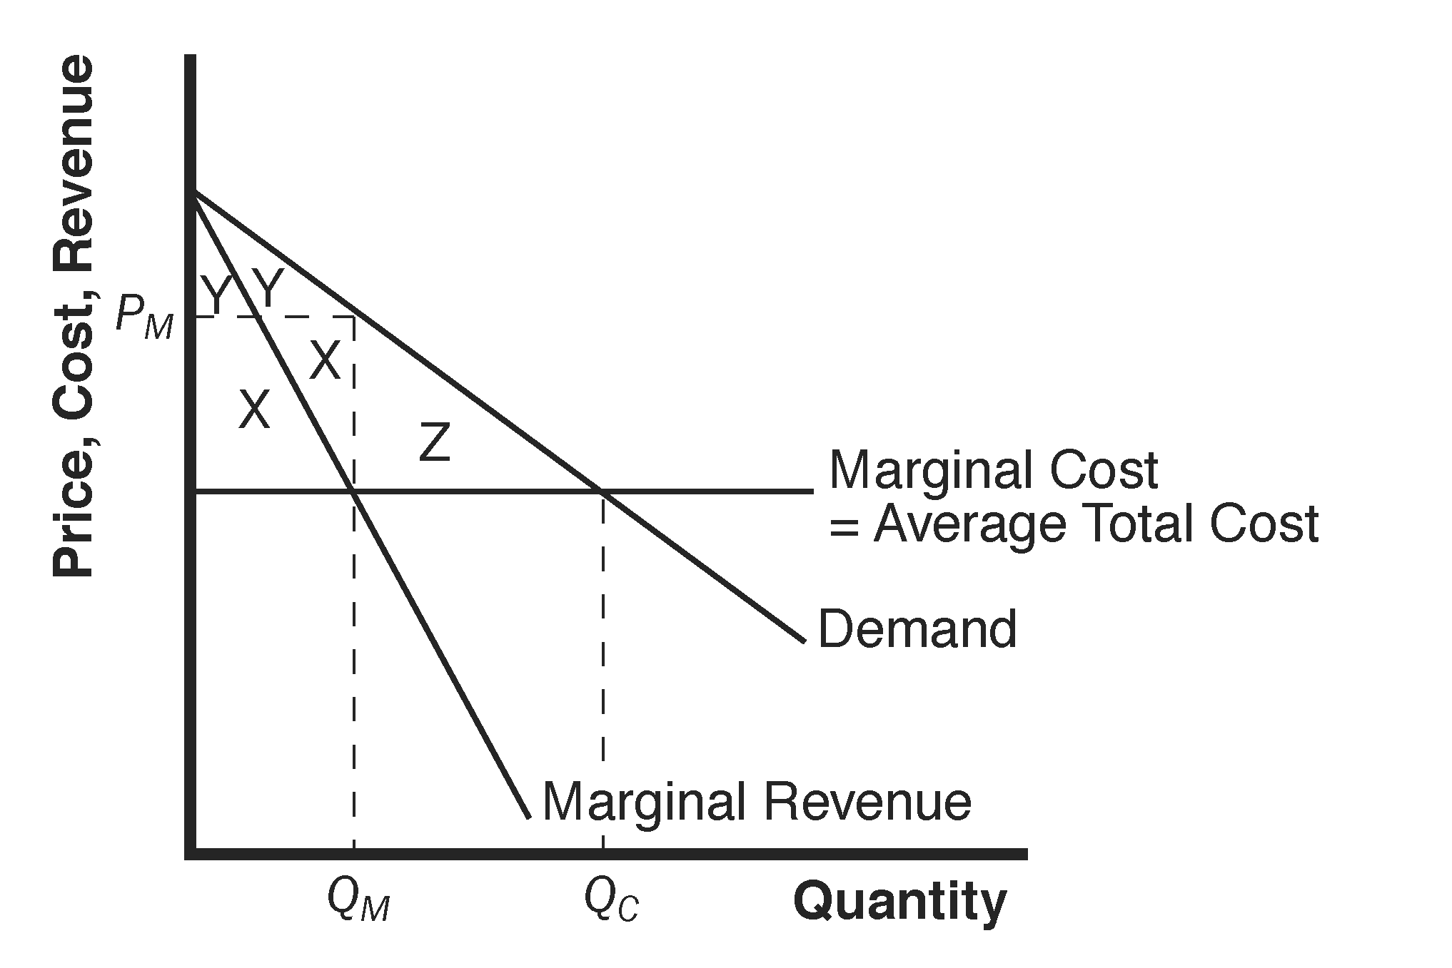

Figure 13

b. The monopolist's profit consists of the two areas labeled X, consumer surplus is the two areas labeled Y, and the deadweight loss is the area labeled Z.

c. If the monopolist can perfectly price discriminate, it produces quantity Q_{C}, and has profit equal to X + Y + Z.

d. The monopolist's profit increases from X to X + Y + Z, an increase in the amount Y + Z. The change in total surplus is area Z. The rise in the monopolist's profit is greater than the change in total surplus, because the monopolist's profit increases both by the amount of deadweight loss (Z) and by the transfer from consumers to the monopolist (Y).

e. A monopolist would pay the fixed cost that allows it to discriminate as long as Y + Z (the increase in profits) exceeds C (the fixed cost).

f. A benevolent social planner who cared about maximizing total surplus would want the monopolist to price discriminate only if Z (the deadweight loss from monopoly) exceeded C (the fixed cost) because total surplus rises by Z – C.

g. The monopolist has a greater incentive to price discriminate (it will do so if Y + Z > C) than the social planner (she would allow it only if Z > C). Thus if Z < C but
Y + Z > C, the monopolist will price discriminate even though it is not in society's best interest.

